FORGOT USER NAME/PASSWORD

Go to www.SMH.com
Click on the ‘Careers’ Link located on the bottom right corner of the SMH Home Page:
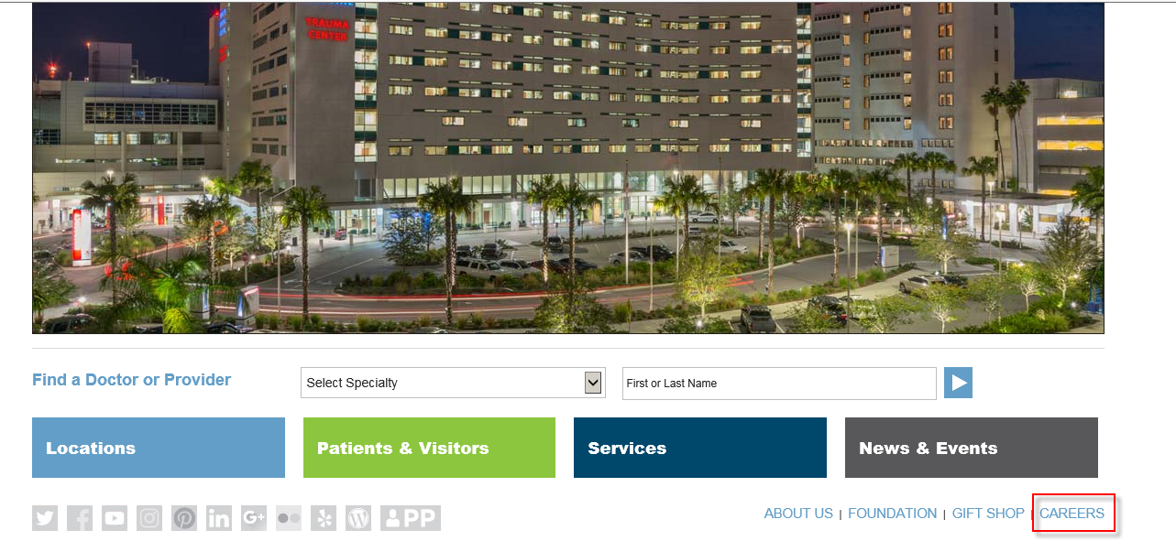

Click on the ‘Talent Profile’ link
Select ‘Review Job Applications’
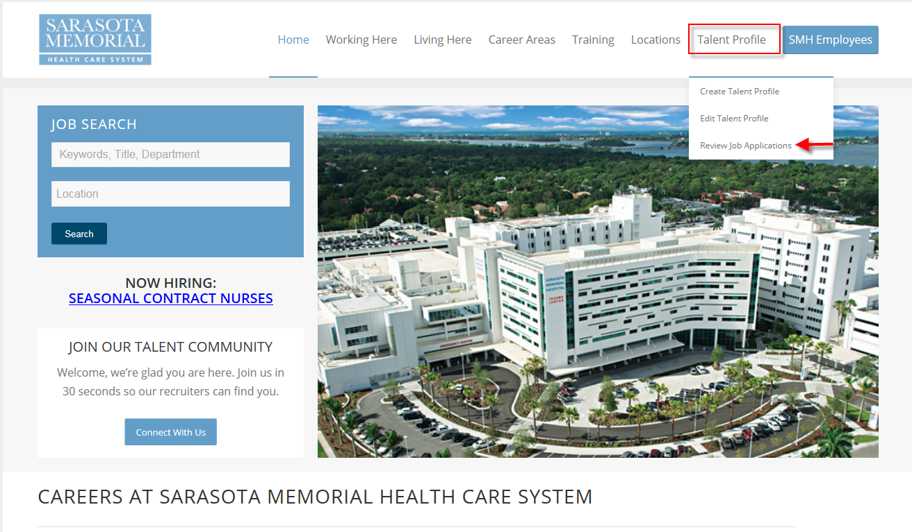

You will be presented with the Job Search Page
Select ‘Sign In’
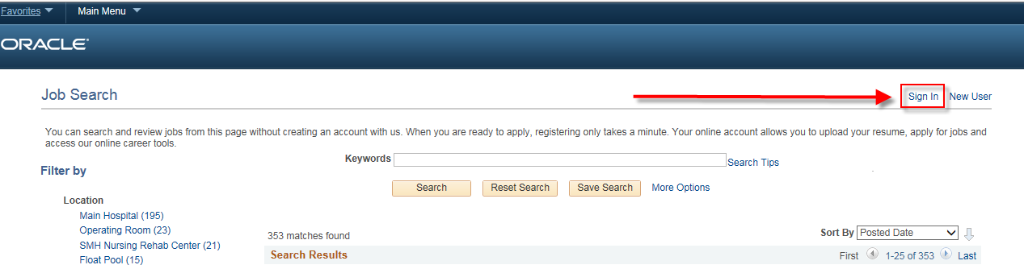

From the ‘Sign In’ Page, you will be able to access your current User Name and/or change your Password.
FORGOT PASSWORD
Select ‘Forgot Password’

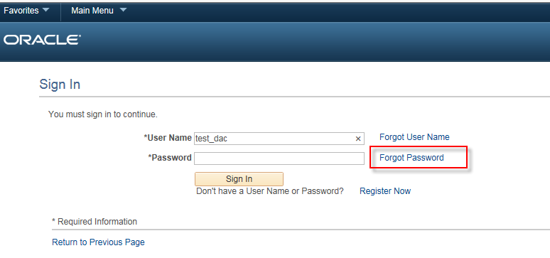
From the Forgot Password Page:
Enter your User Name. Select ‘Email New Password’

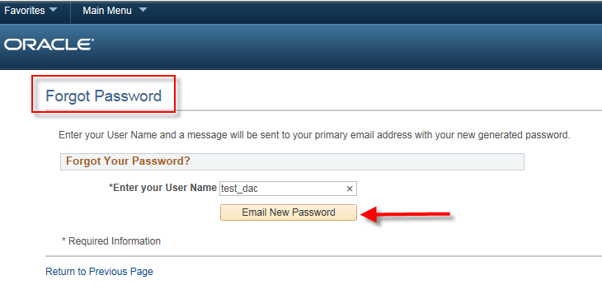

An email will be sent to the Email Address currently on file with a temporary system generated password.
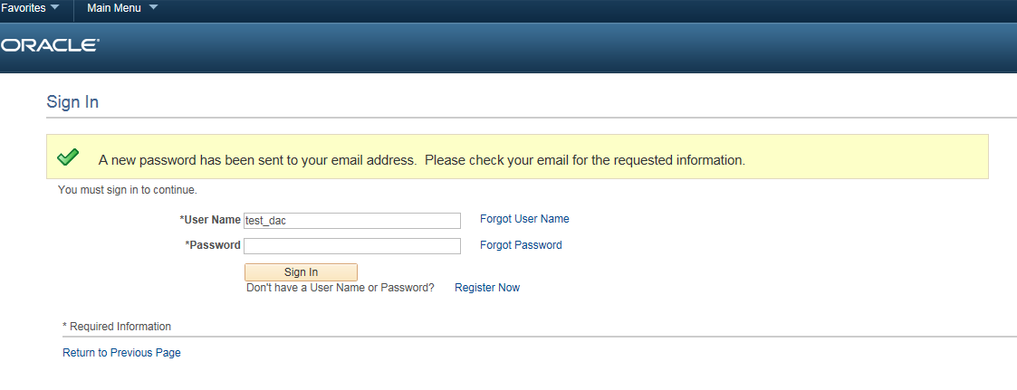
You will receive the following Email.
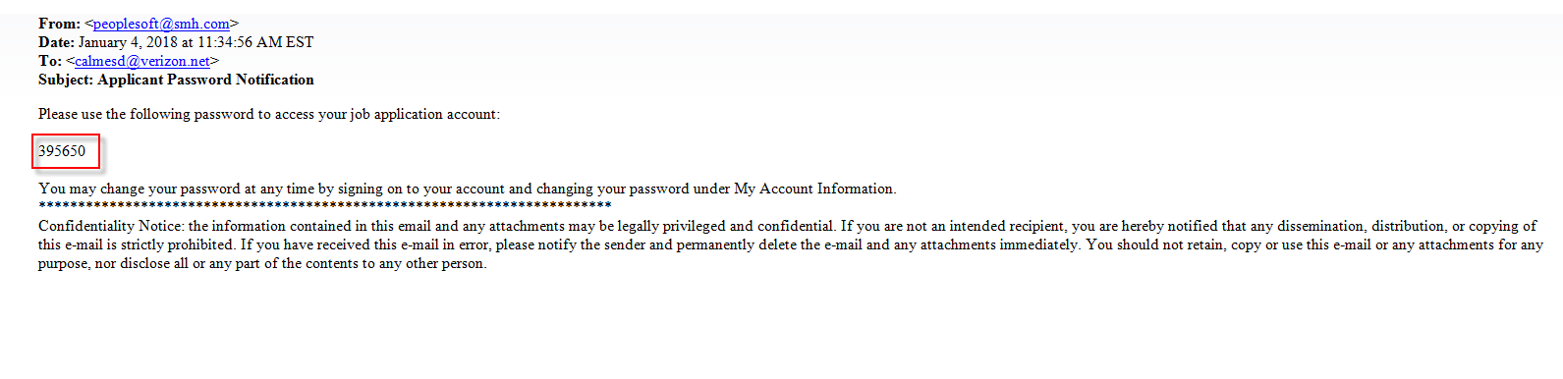

When you login to your account, enter your User Name and the system generated password that was provided in the email.
Upon entering the system generated password, you will be prompted to enter and confirm your new password:
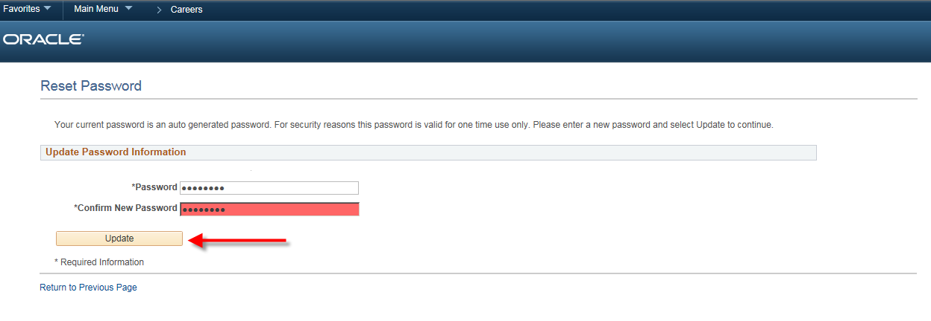

Select Update to save your new Password. You will be signed into the system and returned to the Job Search Page.

Forgot User Name
Select Forgot User Name
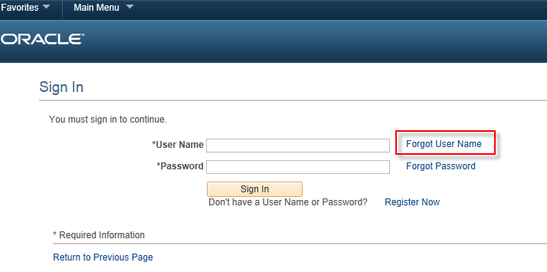

From the Forgot User Name Page:
Enter the Primary Email Address that is currently on file.
Select ‘Email User Name’
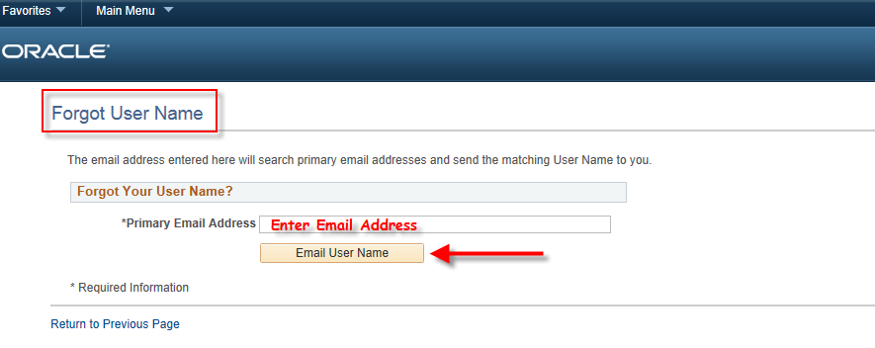

An email will be sent to the Email Address that was entered with your current User Name
You will receive the following Email. 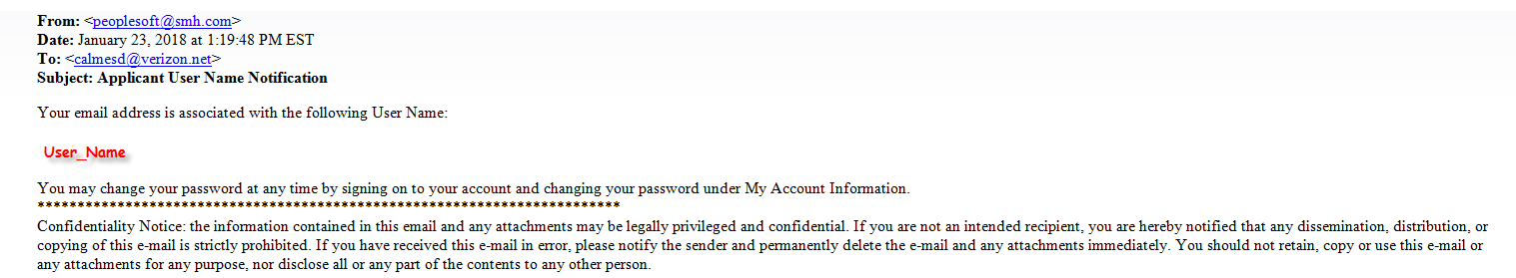

Enter the User Name that was provided in the email. Enter your password and select ‘Sign In’. You will be signed into the system and returned to the Job Search Page.

