The PhD Project Association,
Board of Directors

Ken Bishop, NASBA
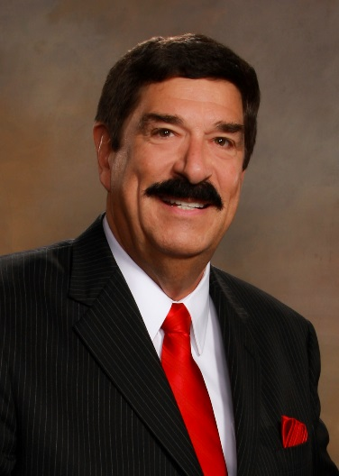
Ken L. Bishop serves as president and chief executive officer of NASBA as well as chief executive officer of NASBA’s ethics arm, the NASBA Center for the Public Trust (CPT). Prior to acceding to the president and CEO role in January 2012, Bishop served as executive vice president and chief operating officer of NASBA, where he was responsible for leading NASBA’s business and testing operations.
Bishop joined NASBA on January 1, 2007, as president and chief executive officer of Professional Credentialing Services (PCS), NASBA’s former wholly-owned subsidiary, and director of CPA Examination Operations. During his tenure as president of PCS, the company grew to provide services to more than fifty professions, both nationally and internationally. Before joining NASBA, Bishop maintained a successful career in the areas of state government and law enforcement, having served in roles including executive director of the Missouri State Board of Accountancy, assistant director of the Missouri Department of Public Safety, undercover narcotics officer, under-sheriff, chief of police and commander of the Missouri Major Case Squad. A Missouri native, Bishop holds a Bachelor's degree in Education from the University of Missouri Columbia, a Master’s degree in Criminal Justice, and is a graduate of Harvard University’s Kennedy School of Government Executive Program. He is also a graduate of the Missouri State Highway Patrol Academy and the Federal Criminal Justice Academy. Currently, Bishop serves as a member of the Vanderbilt University MAcc Advisory Board and the Nashville Downtown Partnership Board of Directors. Among his honors include being named to Accounting Today’s Top 100 Most Influential People in Accounting, from 2011-2014.

Jasmine Brennan, Aerotek
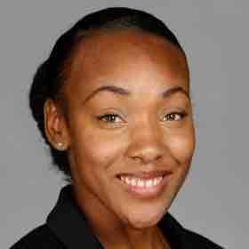
Jasmine Brennan is a member of Aerotek’s Employee Experience team and serves as an Inclusion & Diversity and Corporate Social Responsibility Business Partner. In this role, Jasmine leads a team with responsibility for inclusive leadership training and education, I&D council and employee resource group governance, diversity talent programs, philanthropic giving and employee volunteerism. She is passionate about authenticity, inclusion, and cultivating a sense of belonging and incorporates those areas into both her personal and professional life. Prior to joining Aerotek, Jasmine served in various inclusion and diversity roles within Allegis Group’s network of subsidiary companies and played in integral role in the development of Canon USA’s global diversity and inclusion program and strategy. Jasmine graduated from Canisius College with a Bachelor of Arts in Psychology, New York Institute of Technology witha Master of Science in HR Management, and completed a Diversity Practitioner Certification at Cornell University. She endeavors to model work life balance as a single mother and her four year old son, Liam, is also well known amongst her partners across Aerotek for his occasional visits to the office and attendance at community service events.

Kim Drumgo, AICPA (PhD Project Board Chair)

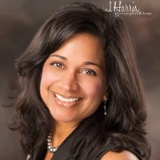
Kim Drumgo is the Director of Diversity and Inclusion at the Association of International Certified Professional Accountants. In her role at the AICPA, Kim provides transformational leadership to drive innovative change in the accounting profession specific to diversity and inclusion. Her role includes developing forward thinking strategies to increase the pipeline of diverse talent and foster inclusiveness across the accounting profession.

Kim also serves as the Vice Chair of the AICPA’s National Commission on Diversity and Inclusion (NCDI), an AICPA committee dedicated to providing thought leadership on the recruitment, retention, and advancement of diverse talent in accounting profession. Kim has led the AICPA to develop best practice toolkits, assessments, and facilitate webinars to help firms and organizations improve their inclusivity. Kim also leads a dynamic team of professionals dedicated to deconstructing the latest insights, analytics, and benchmarks that inform the AICPA’s strategy to support and guide colleges and universities, state societies, and firms and organizations in inclusion. Due to the efforts of her team and NCDI, AICPA was awarded a Leader in Diversity Award by Triangle Business Journal in 2016.

Prior to her role at AICPA, Kim served as the Chief Diversity Official (CDO) of Blue Cross and Blue Shield of North Carolina. As the CDO, Kim was responsible for partnering with human resources and business unit heads to provide internal consulting strategies, tools, and systems to support the enterprise-wide diversity strategy. She led the launch of seven employee resource groups, built the framework for multicultural marketing, and heightened the organizations awareness of healthcare disparities among minorities in North Carolina.

Kim is the chairman of the PhD Project board, an organization that seeks to increase the diversity of business school faculty. She is also a member of the Conference Board Diversity Council which seeks to identify best practices in diversity and inclusion. Kim holds a bachelor of science degree from UNC Chapel Hill in Public Health and a master’s in business administration from the University of Maryland. She is also a certified Project Management Professional and certified in the administration of the Global Mindset Inventory assessment.

Rosanna Durruthy, LinkedIn
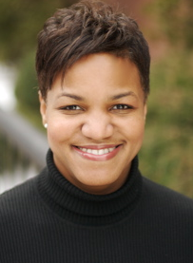
Rosanna is the Head of Global Diversity, Inclusion and Belonging at LinkedIn. In this role, she is helping to realize LinkedIn's vision to create economic opportunity for every member of the global workforce. Rosanna is the lead catalyst for a team that's on a mission to empower our employees, members and customers in realizing their full potential. Our intent is to architect the alchemy of a diverse and inclusive culture that readily enables the power of belonging, for all of our employees, around the world.

Prior to joining LinkedIn, Rosanna was Chief Diversity Officer at Cigna, leading the company’s diversity and inclusion center of excellence practice, supporting Cigna’s mission to help customers improve their health, well-being and sense of security. Operating with a customer centric context, Rosanna frames diversity to drive talent engagement, business growth, customer satisfaction and cross-cultural capabilities for Cigna’s employees worldwide. Rosanna attended Harvard College and has been recognized by Savoy Magazine as one of the 2012 Top Influential Women in Corporate America. In 2002, she was named one of the country’s leading Hispanic women by both Hispanic and Hispanic Business magazines.

David Evans, Dixon Hughes Goodman LLP

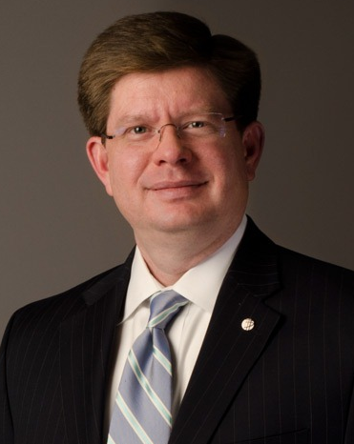
David is Regional Managing Partner for DHG’s South Region and leads the firm's Public Company Tax Outsourcing Practice in Atlanta. He serves clients in multiple industries, with a tax practice focusing on business consulting, transaction planning, structure and implementation, tax consulting for public and privately held corporations and flow-through entities, estate tax and succession planning.

He offers significant experience in finance, mergers and acquisitions, specializing in entity structuring to maximize flexibility and minimize corporate and individual income tax liabilities.

David is a member of the AICPA and GSCPA and serves on the Advisory Boards of St. Jude’s Recovery Center and the University of Tennessee Dept. of Accounting and Information Management Council, and on the Boards of the Metro Atlanta Chamber, Central Atlanta Progress and Damp Kudzu.

Kendra Johnson, Graduate Management Admission Council

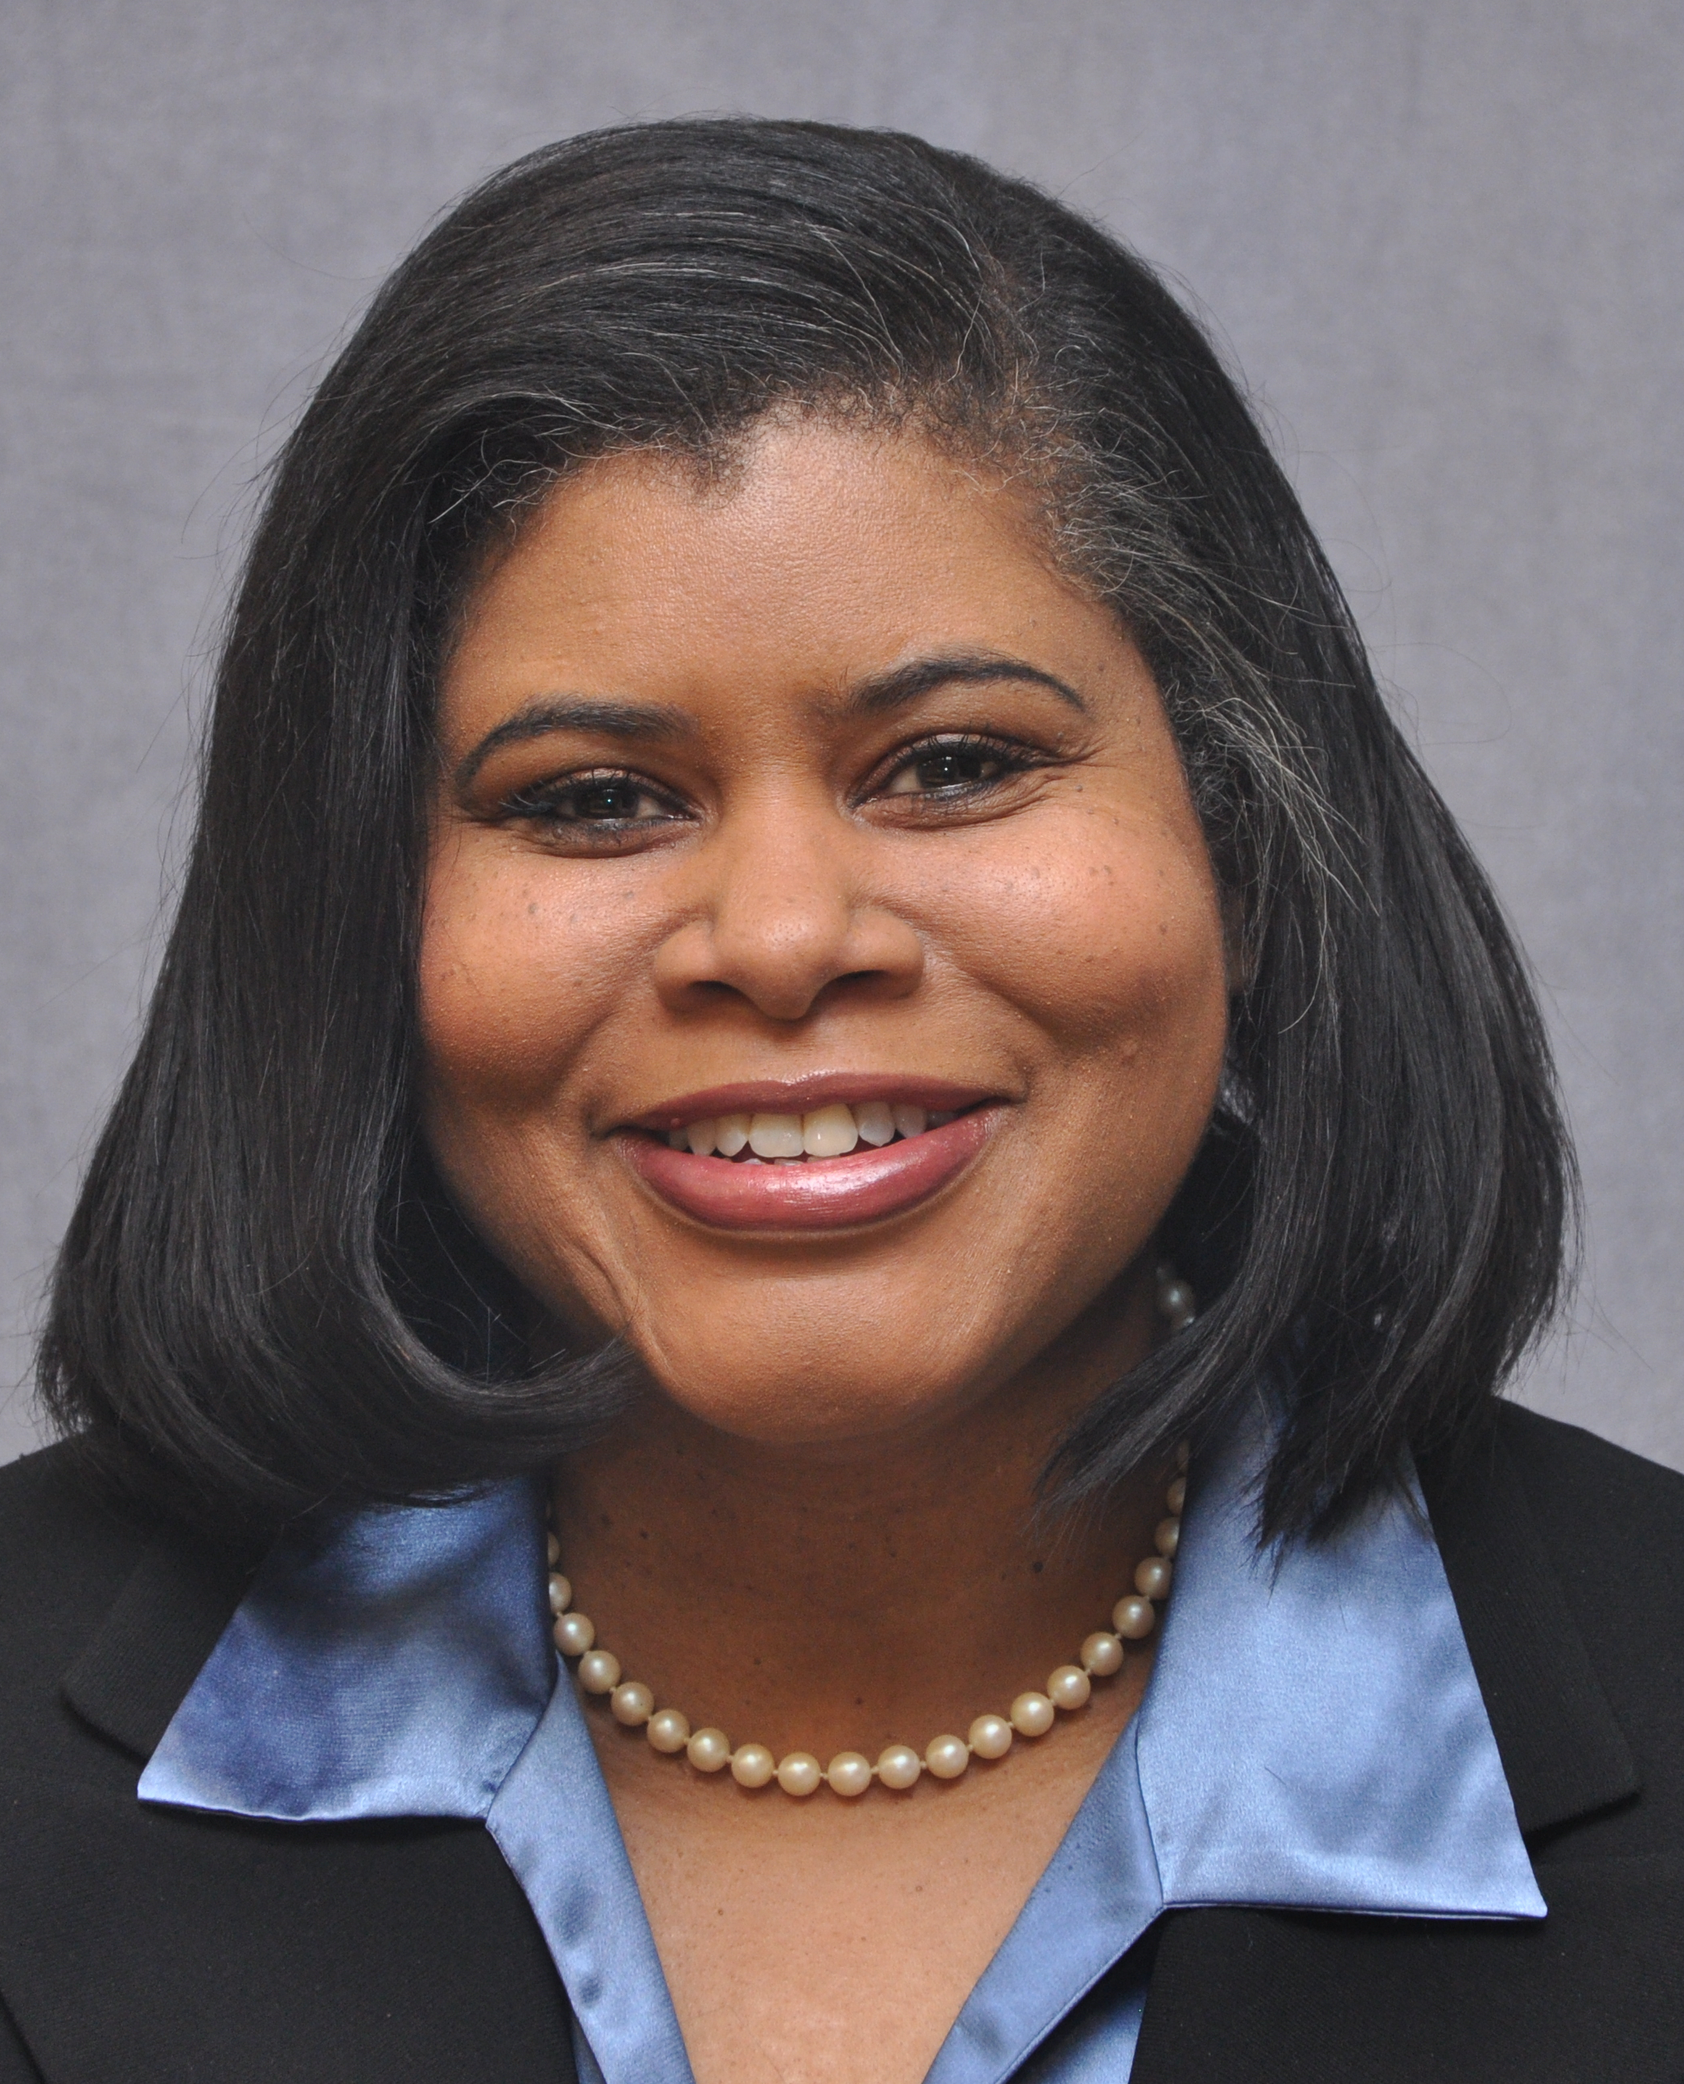
Kendra Johnson is currently the Director, Disability Policy & Services for the Graduate Management Admission Council (GMAC) where she oversees testing accommodations for applicants with all manners of disabilities seeking equal access to the GMAT. Prior to her position with GMAC, she was the ADA/504 compliance officer and director of a college disability support service at the University of Michigan (Flint Campus) and at the University of Toledo. With her strong passion for reaching out to college students with disabilities, she co-authored the book 100 Things Every College Student with a Disability Ought to Know and founded the consulting company, Transition Game Educational Consultants, LLC,now Transition2College.com. She is a frequent speaker at regional and national conferences on the successful transition to college for students with disabilities and at high school college fairs for students with disabilities planning to attend - or thinking of attending college.
As a GMAC director and private high school educational consultant and trainer, she empowers students to remember that “there are no limitations except those that are self-imposed!”
Kendra has also worked as an adjunct university instructor teaching special education courses for future teachers in training, while serving as a full-time college administrator. Kendra is a professional member of the Independent Educational Consultants Association (IECA) and a member of the Association on Higher Education and Disability (AHEAD). Kendra holds a B.A. in American Public Affairs-Social Relations from Michigan State University, a M.A in Rehabilitation Counseling from Michigan State University, and a Doctorate of Education in Curriculum and Instruction from Wayne State University.

Russ Klein, American Marketing Association
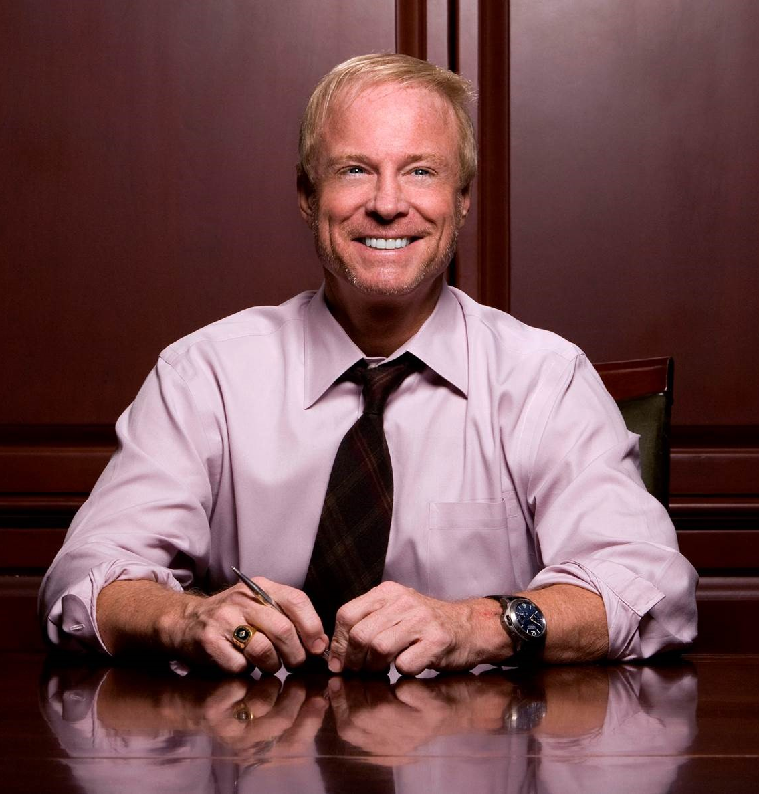
After becoming a Fortune 500 CMO at 29, Russ Klein has gone on to lead marketing and advertising teams in the C-Suite during the past 30 years for well-known world brands like Dr. Pepper/7UP, 7-Eleven, Burger King, Gatorade, and Arby’s. He’s been named to top marketer lists spanning three decades and recognized by AdWeek as “Advertiser of the Decade” for the 2000s. Under his leadership, his teams have earned scores of industry awards for excellence, he’s credited for ushering in the age of digital marketing and has the rare distinction to have led marketing behind three major turnarounds – each shattering records at the time for both growth and return to shareholders. (Dr Pepper Snapple, Burger King, Inspire Brands [Arby’s])
As CEO of AMA, Russ is charged with its transformation to become the essential community for marketers worldwide. Once nicknamed “Flamethrower” by an industry publication for his penchant for the provocative, he now aspires to be the torchbearer for all marketers at the helm of the AMA. Klein is a Distinguished Alumnus and graduate of The Ohio State University and graduate of Harvard Business School’s Advanced Management Program.

Sharon Pierson, The Pierson-Milano Family

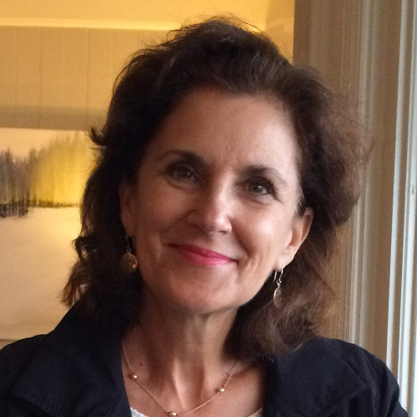
Dr. Sharon Pierson, an adjunct professor at Ramapo College of New Jersey, is proud to represent The Pierson-Milano Family on The PhD Project Board.

Sharon earned her undergraduate degree from University of North Carolina, Chapel Hill, her master’s degree in Curriculum and Teaching, her master’s in Philosophy, and her PhD in History and Education from Columbia University, Teachers College. Dr. Pierson’s historical research of superior, “laboratory” schooling for African Americans during de jure segregation in the South was published by Peter Lang Publishing (2014), ‘Laboratory of Learning’: HBCU Laboratory Schools and Alabama State College Lab High in the Era of Jim Crow. She has presented her research at numerous academic conferences, such as the American Educational Research Association, History of Education Society, Organization of Educational Historians, and the John Dewey Society Centennial. Dr. Pierson has also contributed chapters in: Using Past As Prologue (Information Age Publishing, 2015) and Schools of Tomorrow, Schools of Today: Revisited (Lang, 2016). Sharon teaches courses in the School of Contemporary Arts at Ramapo and is also a professional speaker and coach.

In the nonprofit sector, Sharon currently serves on the President’s Advisory Council, Columbia University, Teachers College, and also serves as Communications Director and Editor of the Trinity Times at Trinity Episcopal Church in Allendale. Sharon has served as a judge at numerous Enactus World Cup competitions, where undergraduate students from all over the world present their entrepreneurial service projects. She has also enjoyed serving in leadership positions for non-profit organizations, such as the Allendale Foundation for Educational Excellence, Bergen County Academies, the Junior League of Bergen County, and Boy Scouts of America, among others.

Sandy Richtermeyer, Institute of Management Accountants

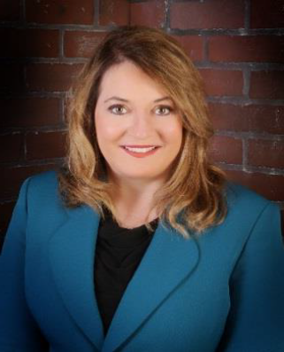
Sandra Richtermeyer, Ph.D., CMA, CPA, is dean of the Manning School of Business at the University of Massachusetts Lowell. She works actively with a variety of professional organizations and is a frequent speaker on professional development, governance, internal control, technology enablement, and performance measurement. Her teaching and research interests are in the areas of corporate governance, accounting information systems, and nonprofit and governmental accounting. She has authored many articles in academic and practitioner publications. Her research publications have featured many topics including technology enablement, enterprise systems, nonprofit accounting, and professional issues for accountants.

In addition to her academic background, she worked as a CPA for many years in Denver, Colo., with a practice focus on compliance, assurance, and systems implementation. Prior to joining the University of Massachusetts Lowell, she was professor of accountancy and associate dean of the Williams College of Business at Xavier University. Prior to that, she was on the faculty at the University of Wyoming for several years, where she also completed her B.S. degree. She is proud to be a fourth generation Wyomingite, as well as a “Triple Buff” as she received her M.S., MBA, and Ph.D. from the University of Colorado.

Richtermeyer has held many leadership roles in a variety of organizations over the past 20 years. She is an active board member in a variety of organizations and regularly consults with and provides training for boards on governance best practices and leadership challenges. In addition, she coaches CEOs with an emphasis on improving communications between board members, the CEO, and senior management. From 2012-2018 she represented IMA® (Institute of Management Accountants) on the Committee on Sponsoring Organizations of the Treadway Commission (COSO). She also recently served on IMA’s Diversity and Thought Leadership Pipeline Committee. She was IMA Global Chair from 2010-2011 and also has more than 20 years of service in local, regional, national, and global IMA roles. She is currently on the board of directors of the Ohio Society of CPAs, Educational Foundation for Women in Accounting, 2018-2019 past-president of Beta Alpha Psi International, and immediate past-president of the American Accounting Association (AAA) Accounting Program Leaders Group. She is also currently a member of the U.S. Comptroller General’s Green Book Advisory Council and the United Nations Internal Control Advisory Committee.

Richtermeyer has also served on many technical advisory boards for organizations such as Microsoft, Oracle, and PeopleSoft. She is the 2013-2014 Ohio Accounting Educator of the Year and the 2011 American Women’s Society of CPAs Educator of the Year.

Tom Robinson, AACSB
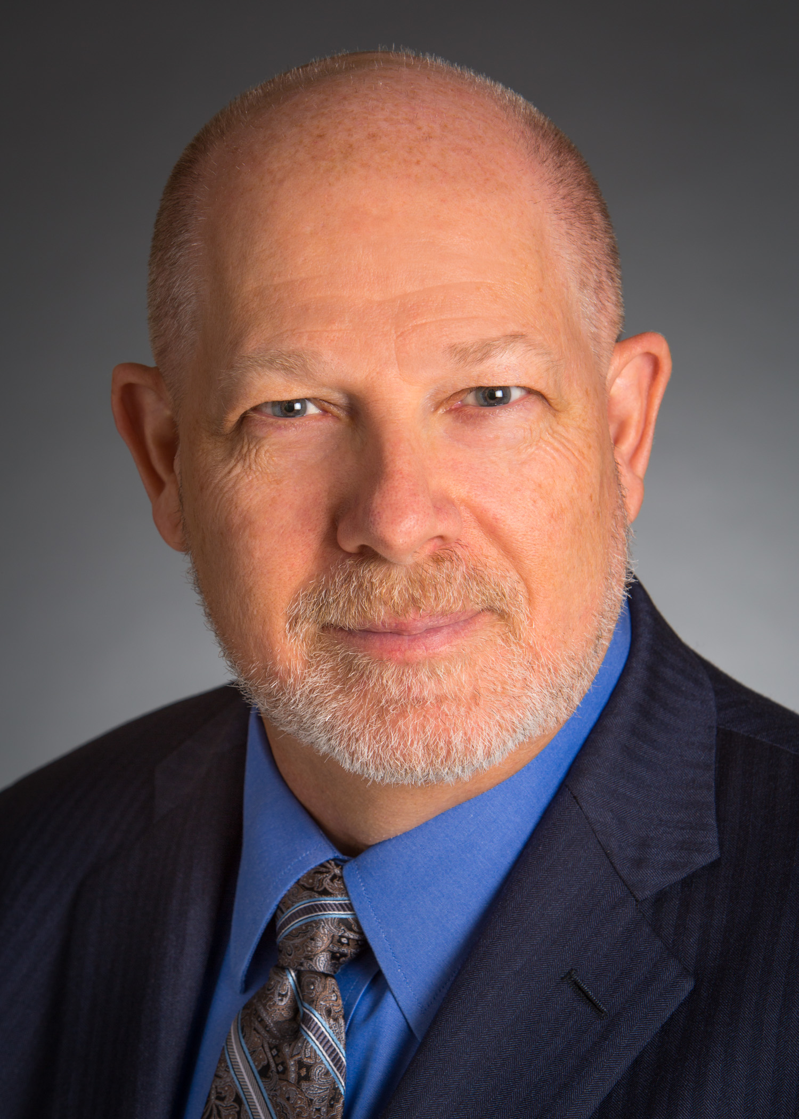
Thomas (Tom) Robinson is president and CEO of AACSB International—The Association to Advance Collegiate Schools of Business (AACSB). Prior to joining AACSB in March 2015, Robinson served as Managing Director Education, and Managing Director of the Americas at the CFA Institute. There he led a cross-functional team which participated in the development of education and engagement strategies for the Americas Region. He also provided vision and leadership for a global team which produced and delivered educational content and programs for candidates, members, investment professionals, and universities. Previously, Robinson served as a tenured faculty member and director of the Master of Professional Accounting and Personal Financial Planning programs at the University of Miami.

Throughout his academic career, Robinson won several teaching awards, published regularly in academic and professional journals, and authored or co-authored many books. As a CFA charterholder, a Certified Public Accountant (CPA), a Certified Financial Planner® (CFP®), and a Chartered Alternative Investment Analyst (CAIA), Robinson practiced public accounting and financial planning for 10 years. He also served as a consultant and investment advisor in the areas of wealth management, financial statement analysis, and valuation. Robinson holds a bachelor’s degree in economics from the University of Pennsylvania, and a master's and doctorate from the Weatherhead School of Management at Case Western Reserve University.

Jose Rodriguez, KPMG LLP
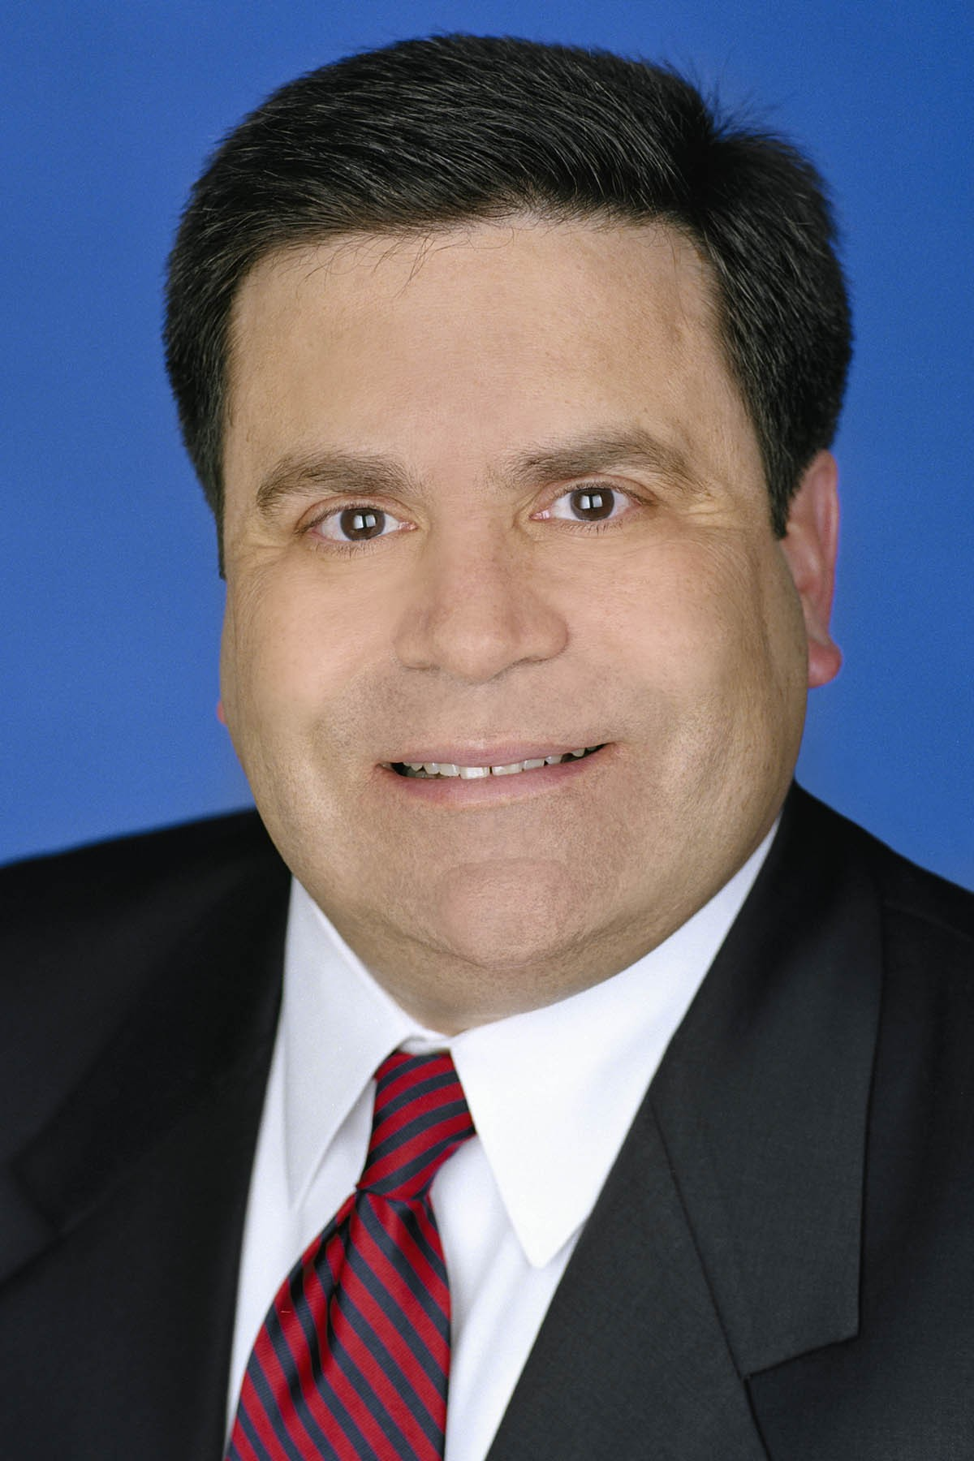

Jose is an audit partner in the New York office of KPMG. He also serves as an SEC Reviewing Partner and Foreign Filing Review Partner on some of KPMG’s most significant accounts.

Jose was admitted to the partnership in 1995, in the Miami office and has done a rotation in KPMG’s national office. Additionally, Jose is a former member of KPMG’s US and Americas Board of Directors, and served as the Lead Director. Jose is currently Chairman of the KPMG Foundation.

Jose’s experience has been with both large and mid-size private and publicly-held companies with primary emphasis in the consumer markets (retail, restaurants and distribution and manufacturing concerns), oil and gas and communications and media sectors. He also has experience with initial public offerings, merger & acquisitions, and International Financial Reporting Standards (IFRS) audits. He has participated in several successful private and public company transitions to KPMG.

Nancy Rogers, Lincoln Financial Group
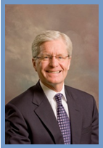
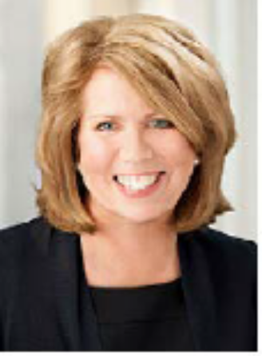
Nancy Rogers serves as president of the Lincoln Financial Foundation, and as senior vice president and head of Corporate Social Responsibility for Lincoln Financial Group. In these roles, Rogers oversees sustainability strategy and practices, corporate philanthropy, and volunteerism. Prior to this role, Rogers was senior vice president of Talent Management and Development, and led programs that advanced the leadership and organizational development priorities of Lincoln. She served as a member of the human resources council responsible for corporate-wide human resources governance.
Nancy earned a bachelor of arts in English from LaSalle University in Philadelphia. She earned a certificate in Executive Leadership Development from the Wharton School, a certificate in Corporate Social Responsibility from Johns Hopkins University, and is certified in sustainability practices by the Institute of Environmental Management and Assessment. She serves as president and director of Lincoln Financial Foundation Board of Directors. Past board service includes Director of Mercy Health System (Finance and Governance Committees), past Commissioner on the Mayor’s Commission on Literacy, the Homeless Advocacy Project (Board Chair); Support Center for Child Advocates; Center for Emerging Visual Artists; Philadelphia Dance Alliance; and United Way of Southeastern Pennsylvania. Rogers is a member of the Forum of Executive Women, the International Society of Sustainability Professionals, and the Conference Board Corporate Contributions Council. She has been recognized by the National Diversity Council as one of the Most Powerful and Influential Women in Pennsylvania.

Blane Ruschak, KPMG U.S. Foundation

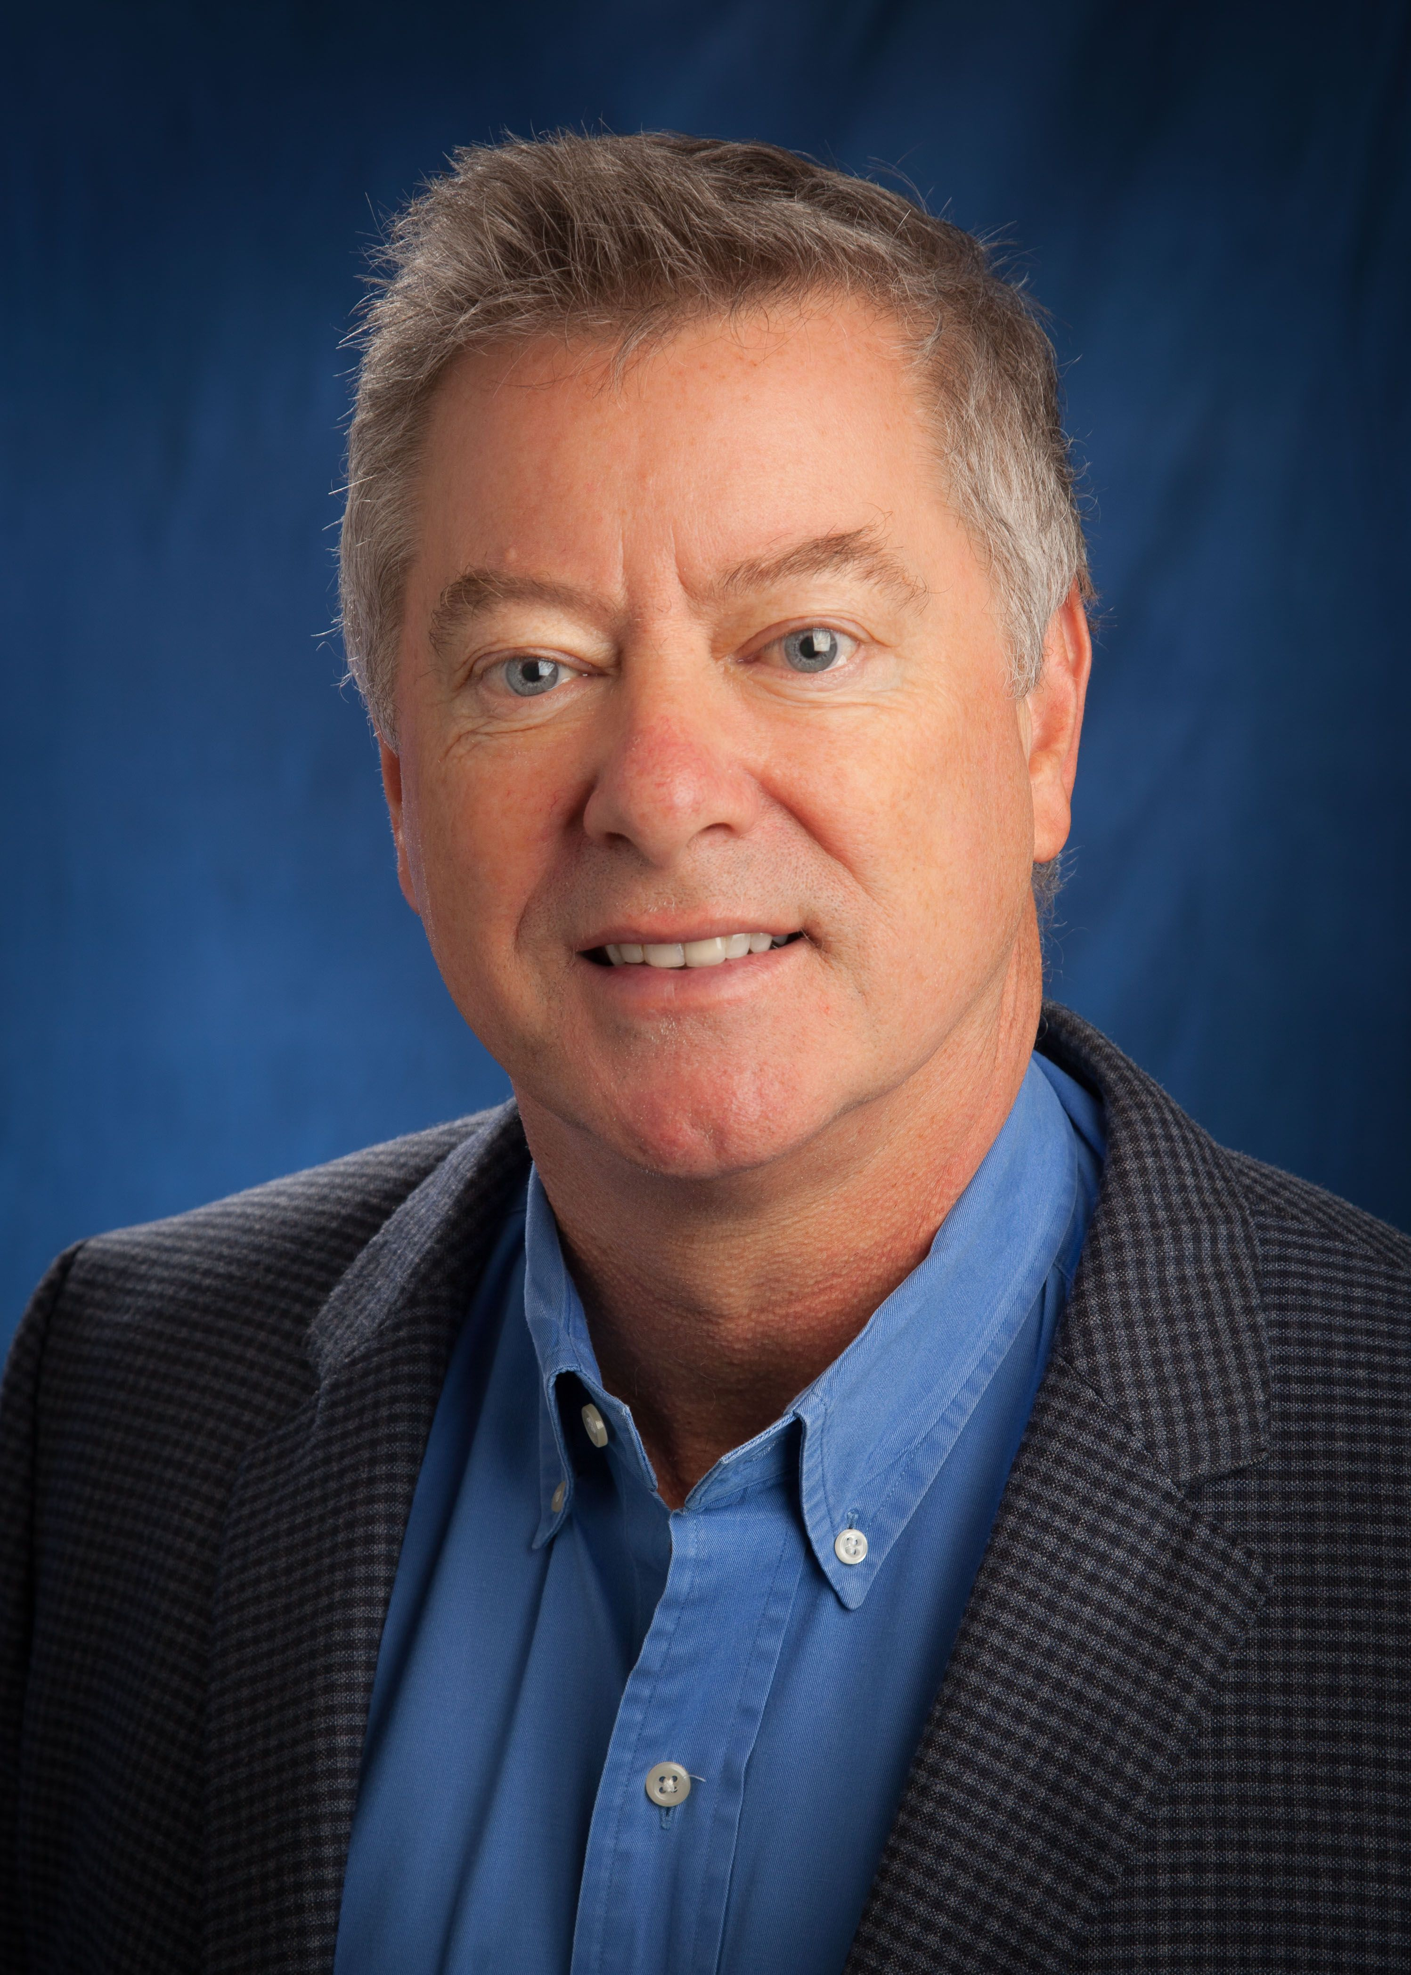
Blane Ruschak’s current role includes serving as the President of both The PhD Project and the KPMG U.S. Foundation, Inc. (Foundation) where he oversees the strategy and operations for the Foundation which includes the Matching Gift Program, Disaster Relief Fund, KPMG Family for Literacy Fund, the Foundation and the Women’s PGA/Future Leaders program. In his previous role as Executive Director of Campus Recruiting and University Relations, he served on the Professional Partner advisory group for Beta Alpha Psi after completing his three year presidency term, served on the Board of Directors of the Education Foundation for Women in Accounting, and served on the AICPA Pre-certification Executive Education Committee (PcEEC), the Accounting Program Leadership Group (APLG) Board of Directors, and the Board of the Federation of Schools of Accountancy (FSA). He lives in Charleston, South Carolina and works out of the Montvale, New Jersey National Office.

Blane attended Rutgers College in New Jersey and graduated with a BS degree in Economics in 1980. He subsequently attended the University of Hawaii at Manoa where he received a master’s degree in Accounting in 1982.

Rebecca Sproul, KPMG LLP

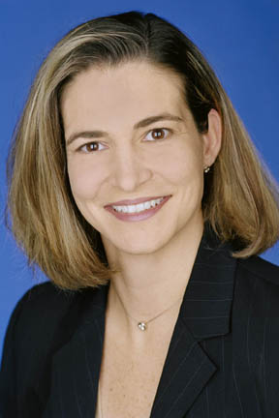
Becky is a KPMG audit partner in the Miami office. She has more than 20 years of experience providing financial statement and internal control audit services, as well as performance improvement advisory services to financial services and software clients. She is primarily responsible for planning and managing financial statement audits for publicly and privately held companies, reviewing SEC filings, researching accounting technical issues, while also managing and developing engagement personnel. She has worked on numerous debt and equity offerings and is an employee benefit plan resource partner as well as a KPMG national instructor for audit methodology and leadership courses.

Becky holds both an MBA and bachelor's degree in accounting from Florida International University. She is a member of the AICPA and is a licensed CPA in Florida and Puerto Rico. Active in her community, Becky is an audit committee member of the United Way of Miami-Dade, and a board member of Our Kids of Miami-Dade/Monroe.

Tracey Sutherland, American Accounting Association

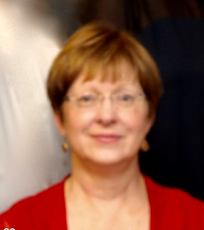
Tracey Sutherland is Executive Director and CEO for the American Accounting Association (AAA). Her position takes her to meetings and campuses around the country where she works with accounting and information systems faculty to support research, curriculum exploration and change, incorporation of information technologies into courses and curriculum. Tracey has consulted and led workshops on the topics of organizational development and change in higher education, teaching and learning, and curriculum development, and her publications include: Active Learning in College Classes: A Range of Options for Faculty, co-authored with Charles C. Bonwell, and "Institutional Assessment has an Unexpected By-Product: Faculty Development" appearing in To Improve the Academy. Before taking her position with the AAA, Tracey founded a teaching and learning center, working with colleagues from all disciplines, and teaching graduate and undergraduate students.

Tracey left campus life to join the AAA professional staff in 1997. She studied, worked, taught, and sometimes lived on college campuses beginning with her freshman year at Stetson University, spending time at Auburn University, Saint Louis University, and Florida State University before beginning the new faculty development program at Truman State University; earning along the way a Ph.D. from FSU and a Master’s degree from Auburn.

Luke Visconti, DiversityInc

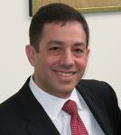
Luke Visconti is CEO Emeritus of DiversityInc Media LLC. He directs all editorial and business operations of the publication. DiversityInc.com reaches more than 1 million unique monthly visitors and DiversityInc magazine has an audited circulation of more than 340,000.

Luke developed and directs the methodology for The DiversityInc Top 50 Companies for Diversity®. His column, “Ask the White Guy,” is a top draw on DiversityInc.com. He is a frequent senior-level lecturer on the business benefits of diversity to corporations, business groups and nonprofit organizations. He is a recognized leader in this field and has appeared on FOX, MSNBC, CNBC and NPR. Mr. Visconti is regularly quoted on diversity issues in publications such as The New York Times, Chicago Tribune, BusinessWeek, Fortune and The Wall Street Journal.

Luke and his former business partner founded DiversityInc in 1998. Prior to entering the publishing industry, he was on active duty as a naval aviator and commissioned officer with the U.S. Navy from 1982 to 1990, and in the reserves until 1992. He holds a Bachelor of Science degree in biology from Rutgers University.

