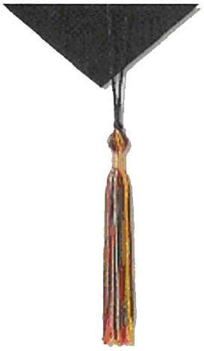
PhD Project Direct Mailer
Information Form
How you can help spread the word!
- Feature The PhD Project in communications to your members (i.e., website, email, newsletters)
- Recognize our members at your annual conference, and/or presenting The PhD Project to local chapters
- Establish a link to our website, www.phdproject.org
- Identify other potential Supply Alliance Partners, or corporate Funders

How we can help spread your word!
- The PhD Project will add your link and logo to our website
- We will spotlight your organization in the ‘PhD Project Highlights’ section of our website as well as Facebook/Twitter
- We will distribute, if appropriate, information about involvement in your organization to our members.
- You are invited to attend The PhD Project Conference held every year in November to network with our participants

Organization Name: ________________________________________________________________

Contact Name:_____________________________________________________________________

Email Address: ______________________________Phone Number: _________________________

Number of names in member database: __________________

Your organization will be listed on the direct mailer as follows: “In cooperation with (your organization name)”
How should the name of your organization appear (please type or write clearly):

___________________________________________________________________________________

I choose the following Option to distribute The PhD Project Direct Mailer: (select those that apply)
___ Option A (label formatted database in an ASCII file, Excel file or Tab Delimited file)
___ Option B (peel off or pressure sensitive mailing labels)
___ Option C (send the direct mailers to your attention for an in-house mailing)
___ Option D (email version of the direct mailer sent to my attention for e-blast to membership)
___ Option E (include our link and logo on your website)

If you choose Option A or B, please send disk or labels by May 31st to:
Zoila Jurado
The PhD Project
3 Chestnut Ridge Road
Montvale, NJ 07645

If you choose Option C, please complete the following information:
Send to (Name): ___________________________________________________
Organization: ___________________________________________________
Address: ___________________________________________________
___________________________________________________

If you choose Option D, please provide email address to send emailer to, for distribution to members and approximate date you would like to distribute the emailer.

Email address: __________________ Approx. date of distribution: ________ Approx. # of recipients: ___

Please fax or email this form by June 1st to Zoila Jurado,

Fax: 201-643-3036 Email: ZJurado@kpmg.com

